Thankyou from Cancer Research UK

Peter Duffy Limited
Park View
Lofthouse
WAKEFIELD
West Yorkshire
WF3 3HA
Cancer Research UK
PO BOX 1561
Oxford OX4 9GZ
United Kingdom
www.cruk.org

Our ref: CCO81815513
17th February 2023 Dear Sir or Madam,
Thankyou for your very generous donation of £4,257.26 on behalf of Peter Duffy Limited. We really appreciate the wonderful support and promise to make it count. As requested, this donation will be used specifically to support research in Yorkshire.
The generosity of supporters like Peter Duffy Limited enables Cancer Research UK to lead the world in discovering and developing newer, kinder treatments and to get closer to cures.
Our research to beat cancer is entirely funded by the public, thanks to your generosity our scientists, doctors and nurses are leading the world in discovering new ways to fight cancer. We’re working to find cures for all cancer, including the one that matters to you.
Research saves lives; we’ve helped to double cancer survival rates since the 1970’s from one in four to two in four today. But we’re not stopping there, we want to accelerate progress and see three in four surviving their diagnosis in the next 20 years.
If you have chosen to hear from us, we’ll keep you updated about the progress we are making and the ways you can support our work in the future. If you would prefer not to hear from us and haven’t told us this already, you can contact us on 0300 123 1022 or at supporter.services@cancer.org.uk to let us know.
Yours Faithfully
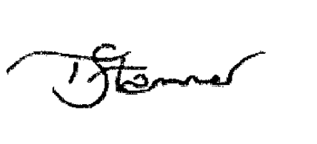
Trudy Stammer
Head of Volunteer Fundraising

